 Check status of Azure services

Login to status.azure.com check if any of the services that we or the customer are using is down in the respective regions.

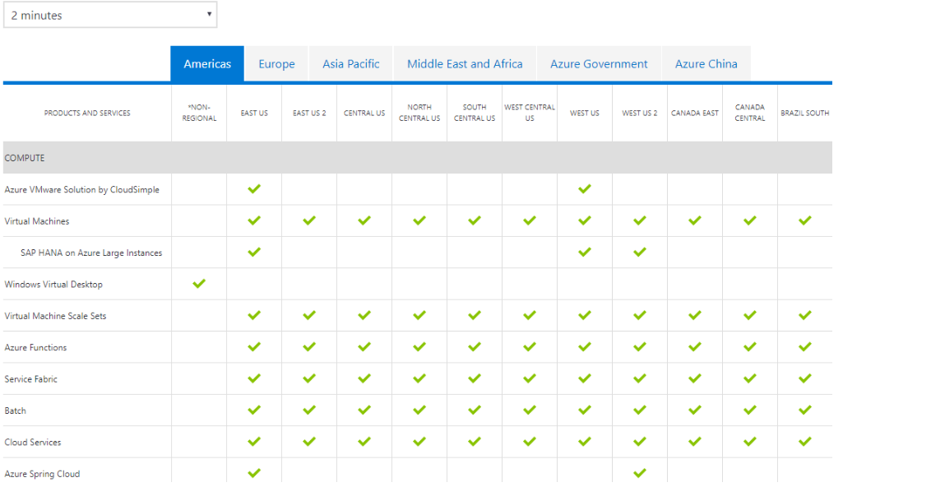

https://status.azure.com/en-us/status